Learning Targets
- I can identify linear equations, intercepts, and zeros.
- I can create a table of values by plugging in x-values to the equation to find the corresponding y-values.
- I can convert an equation into slope-intercept form.
- I can graph linear equations using a table.

What is a Linear Equation?
- An equation that ______________________________ when it is graphed.

Two Common Linear Equation Forms
Standard Form
Slope Intercept Form

[Example] Choose all Linear Equations.

A. 3x +5y = 10 B. y = 2x-1 C. x² + 2x – 3 = 0 D. y = x³ E. 6x – xy = 4

F. $y= \frac{2}{3}x$ G. $y= \frac{5}{x}$ H. y = 3 I. x = 5 J. y = x

How to graph a Linear Equation?
Standard Form | Slope Intercept Form
- Plug in _____to find the y-intercept  - Plug in _____ to find the x-intercept  - Connect x-intercept and y-intercept | 1. Solve for y (____________________)  2. Complete the table or do a _________  - Quick draw: plot a y –intercept then follow the slope

[Example] Graph 2x + 4y = 16

Standard Form Slope Intercept Form
1. Plug in x = 0 to find the y-intercept 1. Solve for y (meaning isolate y)
2. Plug in y = 0 to find the x-intercept 2. Complete the table or do a quick draw
3. Connect x-intercept and y-intercept

x | y
-4
-2
0
2
4

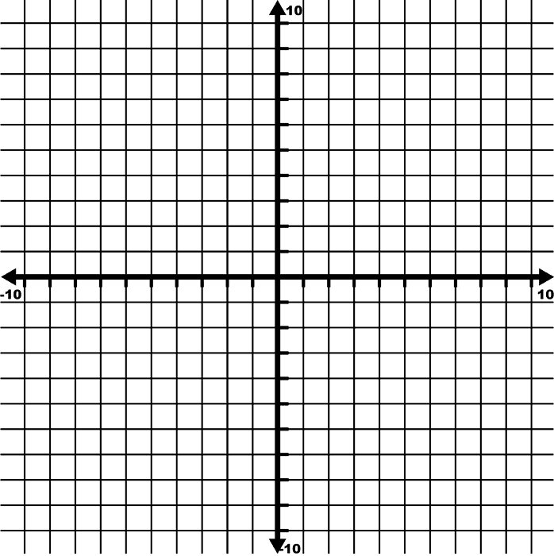

How Does a Table Work?
Starting Equation: $y+3=2x$

Step 1: Get $y$ by itself.

Step 2: Plug in values for $x$ to find $y.$

$$x$$ | $$y$$ | Work Shown
-2
-1
0

Step 3: Plot Points from Table on Graph

Write each linear equation in slope-intercept form (get y by itself).

Why is it important to get y by itself? _________________________________________________________

a) $\frac{2}{3}x+y=7$ b) $-9x=18+6y$

c) $5y=3x+25$ d) $-\frac{1}{2}x+\frac{2}{3}y-8=0$

Examples: Complete the table for each function, then graph

a) $y=-3x+8$

$$x$$
$$y$$

b) $y-6=-3(x+2)$

$$x$$
$$y$$

c) $\frac{8}{3}x-\frac{4}{3}y=-4$

$$x$$
$$y$$

Graphing Vertical and Horizontal Lines
Let’s memorize: HOY VUX
 | Graph Example | Slope | Equation
Horizontal Line | 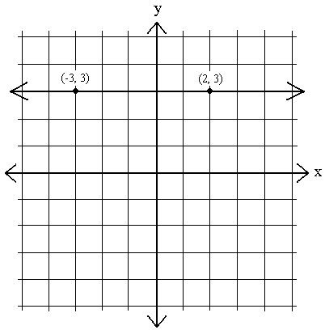 | m =
Vertical Line | 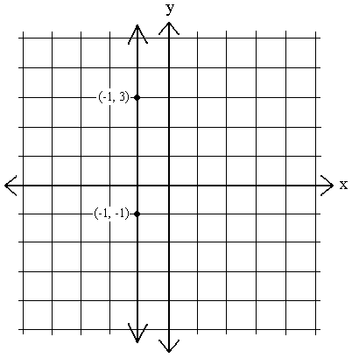 | m =

Graph each equation on the provided coordinate plane.

a) $y=6$ b) $y=-1$ c) $x=3$

d) $x=-2$ e) $y+5=0$ f) $x-3=-1$

Application

a) Determine which ordered pair in the table does not belong to the equation.
$y=-4x+3$

$$x$$ | -2 | -1 | 0 | 1 | 2
$$y$$ | 11 | 8 | 3 | -1 | -5

b) Determine which ordered pair in the table does not belong to the graph.
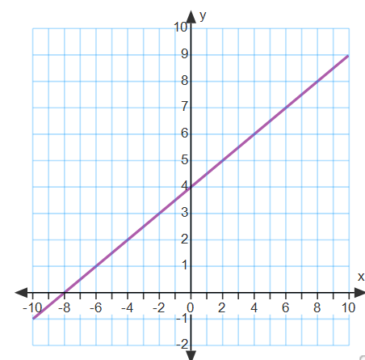
$$x$$ | -8 | -4 | 0 | 4 | 8
$$y$$ | 0 | 2 | 7 | 6 | 8

c) Prove that $(-4, -7)$ is a solution to the equation $y=\frac{1}{2}x-5$
i) Prove graphically ii) Prove algebraically

Extra Practice

- Textbook p. 155-159, 216-219, 233-235

