**Topics List:**

**Unit 1**

Simplifying Expressions

Evaluating Linear Equations

Dimensional Analysis

Consecutive Number Equations

Linear Equation Word Problems

Representing Linear Equations Verbally

Solving and Graphing Linear Inequalities

Writing Linear Inequalities given a Graph

Linear Inequalities Word Problems

Solving Formulas for a variable

Slope of a linear function

Solving Exponential Equations Writing Linear Equations in Slope-Intercept, Point-Slope, and Standard Form

Polynomials

Radical Expressions and Operations

**Unit 2**

Graphing Linear Equations and Inequalities

Solving Systems of Equations by Graphing

Solving Systems of Equations by Substitution

Solving Systems of Equations by Elimination

Solving Linear Equations for a Variable (Including: One, No, and Infinite Solutions

Graphing Systems of Linear Equations

Writing Systems of Equations Given a Graph

Systems of Linear Equations and Inequalities Word Problems

Rate of Change

Arithmetic Sequences

Domain and Range of a Function

Function Notation

Function Notation Word Problems

Domain and Range on a Graph

Combining Functions

Arithmetic Sequences

**Unit 3 (A&B)**

Quadratic Functions

Factoring Quadratics

Solving Quadratics

Graphing Quadratics

Characteristics of Quadratics

Word Problems with Quadratics

Transformations of Quadratic Equations

**Practice Problems:**

**Unit 1**

**Simplify the following expressions. How many terms are in each expression?**

1.  2.

3. 

**Use Dimensional Analysis to convert the following.**

4. Anna is 429,687 seconds old. How old is she in days?

5. Jason is traveling 123 km/hr. How fast is he going in miles per hour?

(Hint: 1 mile = 1609.34 meters)

6. A juice company produced 6,528 mL of orange juice. How many 1 liter bottles can they fill

with this amount?

7. A water faucet is dropping one drop of water every 2 seconds. Estimate how many drops the faucet will

drop in one week if it continues at this rate.

8.  9.  10. 

11.  12.  13. 

14.  15.  16. 

**Unit 2**

**Set up each problem as a linear equation and solve for the unknown value.**

17. The literature club is printing a storybook to raise money. The Print Shop A charges $3 for each book, and $45 to create the film. How many books can be printed if the club has a budget of $350? Write an equation that models this situation and solve for the number of books.

18. A rectangle is 5 feet longer than it is wide. The perimeter of the rectangle is 34 feet. What is the length of the rectangle?

19. Allison earns $5 for every candy bar she sells as part of her fundraiser, and $15 for every bundt cake she sells. In one week, Ashley earned $350 selling candy bars and cakes. Write a linear model that relates the number of candy bars and cakes that Allison sold and then find the number of candy bars she sold if she sold 6 cakes.

20. Write an equation to solve for three consecutive numbers whose sum is 51.

**Solve and graph each inequality. Then write the solution using interval notation.**

21. a. 7*x* + 2(3*x* – 11) ≤ 17 b. Solution using interval notation:

22. a. -6x + 1 > 5 b. Solution using interval notation:

**For each graph, write the corresponding single or compound inequality.**

23. ** ___________________________**

24.  ____________________________

25. Jerry scored 92% and 95% on his first two tests, but his third test score was a 76%, which dropped his

grade average. Write and solve an inequality to determine what score Jerry needs in order to have at least

a 90% average again?

**Solve for the indicated variable**

26.; solve for  27. ; solve for r² 28. , solve for w

**Use the SLOPE formula to find the slope for the following problems:**

29. The line passing through the points (8, 1) and (-3, 0) 30. The line shown on the graph below:

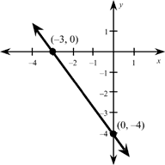

31. Write the equation  in standard form.

32. Write an equation of the line passing through the point  with slope .

Point Slope Form______________________ Slope-Intercept Form________________________

33. Write an equation of the line passing thru (-7, 2) and (-3,-4).

Point Slope Form_____________________ Standard Form________________________

34. Write the equation: 5x – 9y = -12 in slope intercept form.

**Let  Perform the indicated operations for # 73-# 78.**

35.  36.  37. 

**Determine and state the domain and range of each graph and determine if it is a function.**

38. 39. 40.

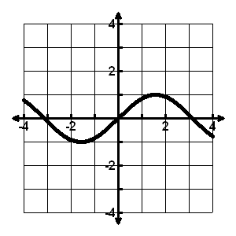 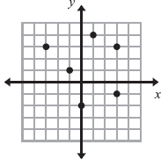 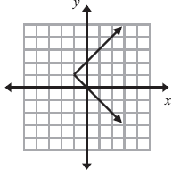

Function? __________ Function? ___________ Function? ____________

Domain: __________ Domain: ___________ Domain: ____________

Range: __________ Range: ___________ Range: ____________

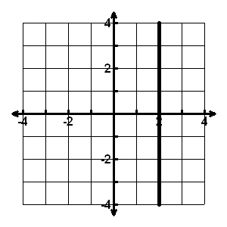41. 42.

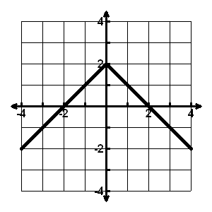

Function? __________ Function? ___________

Domain: __________ Domain: ___________

Range: __________ Range: ___________

[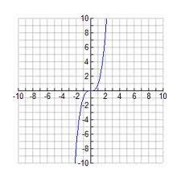](http://www.google.com/imgres?imgurl=http://lj010.k12.sd.us/graph%20x%5e3.gif&imgrefurl=http://lj010.k12.sd.us/&h=300&w=300&sz=5&tbnid=s46VcFacwQSwZM:&tbnh=90&tbnw=90&prev=/search?q=graph+of+x%5e3&tbm=isch&tbo=u&zoom=1&q=graph+of+x%5e3&usg=__tGrsbTVA2vvMdDP5Qv6-sXdl2Kw=&docid=vw7CYpiQrW9JkM&hl=en&sa=X&ei=quLFUNipNMnJ0AGosIDwCg&ved=0CDAQ9QEwAQ&dur=1109)43. Use the graph below to find the following input and output values:

a. f(-2) = c. f(x) = 8

b. f(0) = d. f(x) = 0

1. What is the end behavior of the graph:

*f*(*x*)*→_________* as *x →_________*

*f*(*x*)*→_________* as *x →_________*

44. Identify the following for the graph below:

1. What can the maximum value of f(*x*) be for the function?
2. For what interval is the graph increasing? Write answer in interval notation form.
3. For what interval is the graph decreasing? Write answer as an inequality.
4. Find *x* for when f(*x*) = -2.

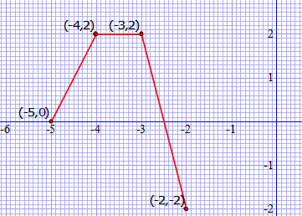

45. Find the Rate of Change between the points (-5, 3) and (-4, -3).

46. Determine if the table represents a linear function, an exponential function or neither. Explain how you

know.

|  |  |  |  |  |
| --- | --- | --- | --- | --- |
| x | 2 | 3 | 4 | 5 |
| y | 3 | -6 | 12 | -24 |

47. Determine if the table represents a linear function, an exponential function or neither. Explain how you

know.

|  |  |  |  |  |
| --- | --- | --- | --- | --- |
| x | 1 | 2 | 3 | 4 |
| y | -1 | 1 | 3 | 5 |

Write the rule for the nth term of the arithmetic sequence in explicit form and find the indicated value. (moved to unit 2 for 2015)

48. -10, -4, 2, 8, 14 …. 49.  50. 

Explicit Rule________________ Explicit Rule__________________ Explicit Rule _______________

_________________ _________________ __________________

51. Given the arithmetic sequence: -6,-11,-16,-21,… write the explicit formula for the nth term,

then find the 20th term.

.

52. For the given arithmetic sequence, write the recursive formula for the nth term and find the next three

terms. 

Write the rule for the nth term of the arithmetic sequence in explicit form and find the indicated value.

53.  54. 

Explicit Rule_______________ Explicit Rule ______________

Find: Find:

_________________ _________________

55. A company that fails to meet EPA pollution standards by a pre-assigned date is fined $1000 on the first

day, $1200 on the second day, $1400 on the third day, $1600 on the fourth day and so on.

Arithmetic or Geometric_________________________________

Explicit Formula_________________________________

What was the company’s fine on the 12th day after the deadline?________________

56. Swine flu has hit in Porkopolis again, and it is extremely contagious. Maddie catches it, and even

though she is complaining of a fever, she goes to school the next day and infects 6 of her friends. Each

newly infected student passes the virus to 6 new students in the next hour. This pattern continues until

all students in the school are infected and Porkopolis High School shuts down for a week.

Arithmetic or Geometric_________________________________

Explicit Formula_________________________________

How many students are infected in 4 hours (by lunch time)________________

**Determine if the following ordered pairs are solutions of the inequalities (show work)**

57. x + 2y ≤ -3 ; (-5, 1) 58. 4x + 3y > 6; (½, 1) 59. -8x – 5y < 10; (-1, -2)

**Graph the following inequalities in the coordinate plane. Graphs must be neat and legible and y-intercepts MUST BE LISTED AS POINTS!!!**

|  |  |  |
| --- | --- | --- |
| 60.  Slope: y-int:  Name a point that is a solution: | 61.  Slope: y-int:  Name a point that is NOT a solution: | 62.  Slope: y-int:  Name a point that is a solution: |

63. Graph the system of inequalities: y + x > +1

y> x - 5

64. Mrs. Daas really loves working puzzles and is always at Barnes and Noble buying more puzzle books.

She realizes that she needs to put herself on a puzzle budget. Ken-Ken puzzle books are $8, crossword

puzzle books are $12, and she has decided to allot $240 this year for buying the books.

|  |  |  |  |  |  |  |  |  |  |  |  |  |  |  |  |  |
| --- | --- | --- | --- | --- | --- | --- | --- | --- | --- | --- | --- | --- | --- | --- | --- | --- |
|  |  |  |  |  |  |  |  |  |  |  |  |  |  |  |  |  |
|  |  |  |  |  |  |  |  |  |  |  |  |  |  |  |  |  |
|  |  |  |  |  |  |  |  |  |  |  |  |  |  |  |  |  |
|  |  |  |  |  |  |  |  |  |  |  |  |  |  |  |  |  |
|  |  |  |  |  |  |  |  |  |  |  |  |  |  |  |  |  |
|  |  |  |  |  |  |  |  |  |  |  |  |  |  |  |  |  |
|  |  |  |  |  |  |  |  |  |  |  |  |  |  |  |  |  |
|  |  |  |  |  |  |  |  |  |  |  |  |  |  |  |  |  |
|  |  |  |  |  |  |  |  |  |  |  |  |  |  |  |  |  |
|  |  |  |  |  |  |  |  |  |  |  |  |  |  |  |  |  |
|  |  |  |  |  |  |  |  |  |  |  |  |  |  |  |  |  |
|  |  |  |  |  |  |  |  |  |  |  |  |  |  |  |  |  |
|  |  |  |  |  |  |  |  |  |  |  |  |  |  |  |  |  |
|  |  |  |  |  |  |  |  |  |  |  |  |  |  |  |  |  |

1. Assign meaning to the variables x and y
2. Write an equation of a line in standard form to

represent Mrs. Daas’s puzzle budget for the year.

1. Graph the line using the x and y intercepts.

LABEL the axes of the graph and the intercepts.

1. If Mrs Daas ends up buying 25 Ken-Ken puzzle books this year, how many crossword puzzle books can she buy and still meet her budget? Show your answer graphically AND algebraically.
2. Graph the system and state the solution. 

66. Solve the system using either **SUBSTITUTION** 67. Solve the system using **SUBSTITUTION**

**or ELIMINATION**. or **ELIMINATION**.

 

Use the following results of solving a system algebraically to state how many solutions the system has. Draw a sketch of the solutions.

68. 0 = 6 69. 8 = 8 70. x = 5 and y = -3

**Graph the following systems of linear inequalities and shade the solution area.**

71.  72. 

73.  74. 

**For the following graphs, write the corresponding system of inequalities**

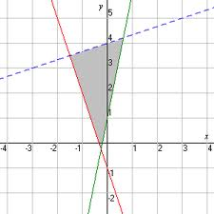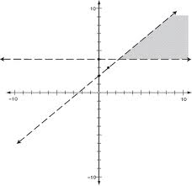

75. 76.

System: System:

**The following are word problems involving systems of linear equations and inequalities. Make sure on each problem that you state the meaning of x and y and show all work involved in solving. Problems involving graphs should include graphs that are labeled with intercepts with the solution area shaded neatly.**

|  |  |  |  |  |  |  |  |  |  |  |  |  |  |  |  |  |
| --- | --- | --- | --- | --- | --- | --- | --- | --- | --- | --- | --- | --- | --- | --- | --- | --- |
|  |  |  |  |  |  |  |  |  |  |  |  |  |  |  |  |  |
|  |  |  |  |  |  |  |  |  |  |  |  |  |  |  |  |  |
|  |  |  |  |  |  |  |  |  |  |  |  |  |  |  |  |  |
|  |  |  |  |  |  |  |  |  |  |  |  |  |  |  |  |  |
|  |  |  |  |  |  |  |  |  |  |  |  |  |  |  |  |  |
|  |  |  |  |  |  |  |  |  |  |  |  |  |  |  |  |  |
|  |  |  |  |  |  |  |  |  |  |  |  |  |  |  |  |  |
|  |  |  |  |  |  |  |  |  |  |  |  |  |  |  |  |  |
|  |  |  |  |  |  |  |  |  |  |  |  |  |  |  |  |  |
|  |  |  |  |  |  |  |  |  |  |  |  |  |  |  |  |  |
|  |  |  |  |  |  |  |  |  |  |  |  |  |  |  |  |  |
|  |  |  |  |  |  |  |  |  |  |  |  |  |  |  |  |  |
|  |  |  |  |  |  |  |  |  |  |  |  |  |  |  |  |  |
|  |  |  |  |  |  |  |  |  |  |  |  |  |  |  |  |  |

77. A farmer is considering what to plant on his farm. He wants to plant both corn and alfalfa. The seed for corn costs $15 per acre and the seed for alfalfa costs $20 per acre. The farmer can only spend $1200 on seed. In addition, he only has irrigation to plant a total of 100 acres of land.

1. Define the variables and label each axis.
2. Write and graph a system of linear inequalities

to represent the situation.

1. Graph the inequalities using x and y intercepts.
2. Is it possible for the farmer to plant 50 acres of corn

and 60 acres of alfalfa? Explain why or why not and support your answer on the graph.

78. You sold 72 boxes of candy for your marching band fundraiser. The large size box costs $3.50 each and

the small size box costs $2.00 each. If you sold $187.50 worth of candy, how many boxes of each size

did you sell?

79. You and a friend go to Taco Bell for lunch. You order three soft tacos and three burritos and your bill

totals $11.25. Your friend’s bill is $10 for four soft and two burritos. How much do soft tacos cost? How

much do burritos cost?

**Unit 3**

**Factor** the polynomials.

80.  81. 

82.  83. 

84.  85. 

**Solve** the following quadratic equations by factoring.

86.  87. 

88.  89. 

90.  91. 

Use the Quadratic Formula to solve each equation.

92.  93. 

Solve by completing the square.

94.  95. 

Write the equation in vertex form of the quadratic equation that has been...

96. a) shifted to the right 4 and up 3

b) reflected over the x-axis and shifted left 11

c) moved down 17

d) reflected over the y-axis, shifted left 9 and down 8

97. One side of a rectangle is 3 ft shorter than twice the other side. Find the sides if the perimeter is 24 ft.

Jason jumped off a cliff while vacationing in Acapulco. His height as a function of time could be

modeled by the function h(t)= -16t2 +16t+480 where t is the time in seconds and h is the height in

feet.

98. How long did it take Jason to reach maximum height?

99. What was the highest point Jason reached?

100. After how many seconds did Jason hit the water?

**Unit 4**

**Fill in the t-chart and graph the following exponential equations:**

|  |  |  |
| --- | --- | --- |
| **x** | **y** | **Point**  **(x,y)** |
|  |  |  |

|  |  |  |
| --- | --- | --- |
| **X** | **y** | **Point**  **(x,y)** |
|  |  |  |

1.  2. 

Asymptote: Asymptote:

**State whether the following equations represent exponential growth or exponential decay:**

3.  4.  5.  6. 

_____________ _____________ ______________ ______________

7. A population of 290 animals in the wild increases at an annual rate of 9%.

1. Write an exponential model for the number of animals in this population after *t* years.
2. Calculate the number of animals in the population after 5 years (to the nearest whole number).

8. The population of a large city is declining by a rate of 1.2% annually. If there were 3,390,000 residents of the

city in 2002, predict how many (to the nearest thousand) will be living in the city in 2010.

9. You deposit $1000 in graduation gifts in an account paying 6% annual interest compounded monthly. Find the amount of money that will be in the account after 4 years.

10. Find the principal value of an investment for which you want $45,000 on after 18 years in an account paying 8.5% annual interest compounded semiannually.

11. Given the sequence 3,12,48, 192,…

a. Write the recursive formula. b. Find the next two terms.

c. Write the explicit formula. d. Find the 25th term.

12. An exponential function $f\left(x\right)=a^{x}$ may be as complicated as $f\left(x\right)=ba^{c(x-d)}+k$. In this form it

may be graphed by transforming the parent graph.

1. Which variable indicates the vertical stretch/shrink?
2. Which variable would have to be negative to reflect the graph across the x-axis?
3. Which variable would shift the graph vertically?
4. Which transformation does $(x-d)$ indicate?
5. Which variable would have to be negative to reflect the graph across the y axis?

**Now that you have completed this Review Packet, make sure you do the following:**

**1. Check your solutions when the answer keys are provided.**

**2. Mark any that are incorrect or need additional work.**

**3. Go back and REWORK any problem with errors. Do not assume that because you “see” the**

**correct answer, you know how to do the problem correctly. Rework them so that you know**

**that you can actually do them.**