Practice Worksheet Scatter Plot and Line of Best Fit Name__________________________

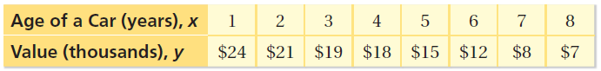
1 2 3 4 5 6 7 8 9 10
Dollar value
in Thousands
15
10
5
0
25
20
Age of car in years

1) What is the domain of the function? (Hint: smallest x-value and largest x-value)

2) What is the range of the function? (Hint: smallest y-value and largest y-value)

3) What is the function type, direction and strength?

4) Using technology we found the equation of the line to be $y=-2x+25$. Using the given equation predict the value of a car that is 3 and a half years old.

5) Interpret the slope of $\frac{-2}{1}$ in the context of the problem. (Hint: age of car and dollar value)

6) Interpret the y-intercept of 25 in the context of the problem.

7) Describe the relationship (if any) between car age and car value.
The graph below displays the height and weight of several students. Use the graph to answer questions 8-14.
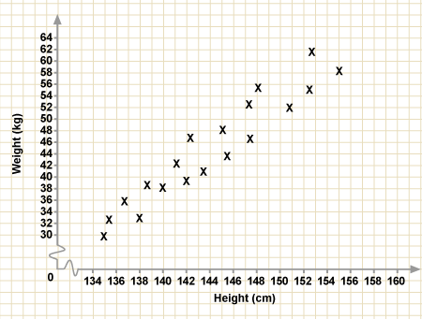
8) What is the expected weight of someone who is 150 centimeters tall?

9) What is the domain of heights?

10) What is the range of weights?

11) Does the function appear to be linear?

12) If the function does appear to be linear then describe the relationship.

13) Estimate the correlation coefficient and use words to describe the direction and strength of the line of best fit.

14) Which one of the following equations is most likely the equation of the line of best fit?

A) $y=-\frac{4}{3}x-170$ B) $y=\frac{3}{2}x-171$ C) $y=10x-165$ D) $y=\frac{5}{2}x+150$

The following chart gives information on 10 high school students. The data shows how many hours per week each student watched and what their GPA is. Use the chart to answer questions 8-14 below.
Student | Hours per week watching tv | GPA
1 | 41 | 2.5
2 | 22 | 3.5
3 | 32 | 3.0
4 | 35 | 2.8
5 | 16 | 3.7
6 | 26 | 3.4
7 | 39 | 2.9
8 | 24 | 3.6
9 | 11 | 3.8
10 | 5 | 3.9

15) Create a scatter plot using the data in the chart above, and then draw the line of best fit.
16). Estimate the correlation coefficient, and use words to describe the direction and the strength.

17) We used technology to find the equation of the line to be $y=-.05x+4$. Using the equation what GPA would you expect someone to have if they watched TV for 40 hours?

18) In the equation what does the -.05 value for slope mean? What does the 4 value for y-intercept mean?

19) Describe the relationship (if any) between number of hours watching TV and GPA.
20)
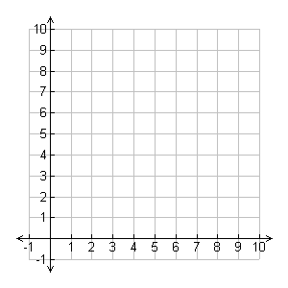
Which equation best fits the data?
- y= $\frac{1}{2}x+8$ b. y= $-\frac{1}{2}x+8$ c. y= $-5x-6$ d. y= 3x – 8

21)
Which equation best fits the data?
- $y=2x-5$ b. $y=2x+2$ c. $y= -\frac{1}{2}x$ d.$y=\frac{3}{4}x+5$

