Sec 5.3 – Average Rate of Change Comparison
Linear, Quadratic, or Exponential Functions Name:

- Find the average rate of change from x = – 1 to x = 2 for each of the functions below.

- $a\left(x\right)=2x+3$ b. $b\left(x\right)=x^{2}-1$ c. $c\left(x\right)=2^{x}+1$

d. Which function has the greatest average rate of change over the interval [ – 1, 2]?

- Find the average rate of change on the interval [ 2, 5] for each of the functions below.

- $a\left(x\right)=2x+1$ b. $b\left(x\right)=x^{2}+2$ c. $c\left(x\right)=2^{x}-1$

d. Which function has the greatest average rate of change over the interval x = 2 to x = 5?

- In general as x→∞, which function eventually grows at the fastest rate?

- $a\left(x\right)=2x$ b. $b\left(x\right)=x^{2}$ c. $c\left(x\right)=2^{x}$

M. Winking Unit 5-3 page 130

- Find the average rate of change from x = – 1 to x = 2 for each of the continuous functions below based on the partial set of values provided.
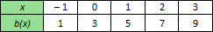
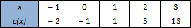
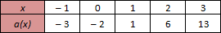
- b. c.

d. Which function has the greatest average rate of change over the interval [ – 1, 2]?

- Consider the table below that shows a partial set of values of two continuous functions. Based on any interval of x provided in the table which function always has a larger average rate of change?
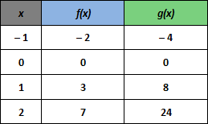

- Find the average rate of change from x = 1 to x = 3 for each of the functions graphed below.
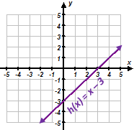
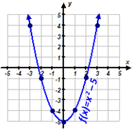
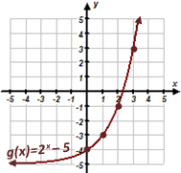
- b. c.

d. Find an interval of x over which all three graphed functions above have the same average rate of change.
M. Winking Unit 5-3 page 131

