- Navigate to the Fulton County Schools district website, http://www.fultonschools.org
- Click on the menu in the top left corner.

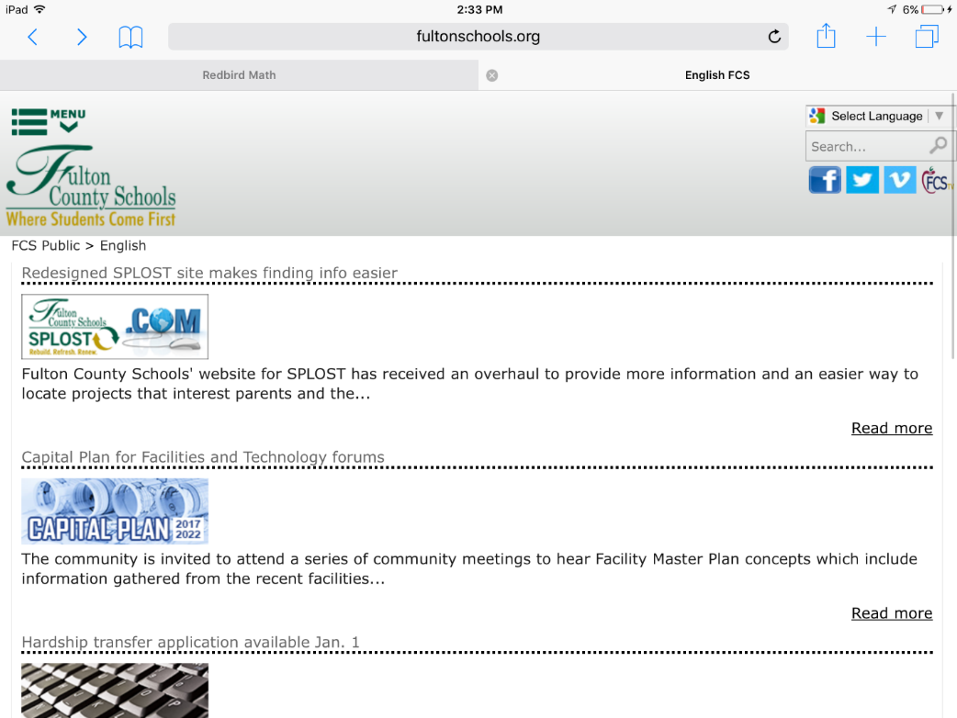
- Under the Students and Parents navigation tab, click on Resources
- Under the Students section, click on the MCGRAW HILL link
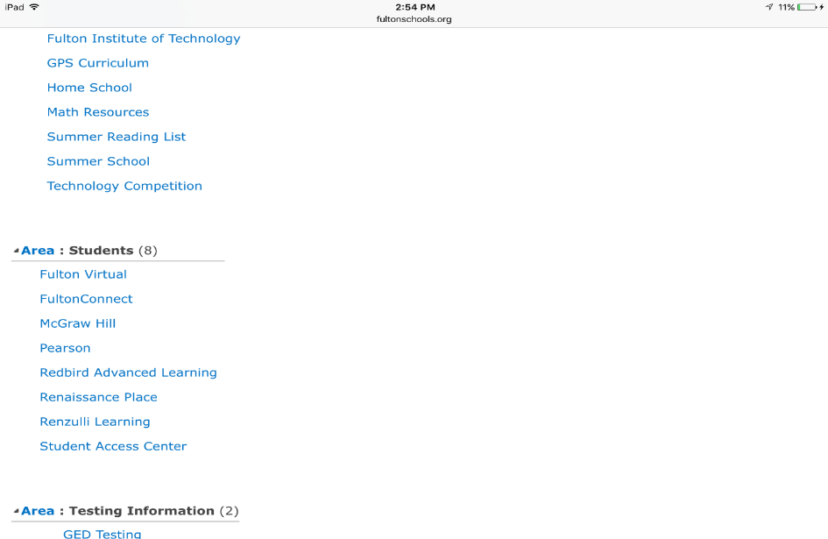

Students should click McGraw Hill

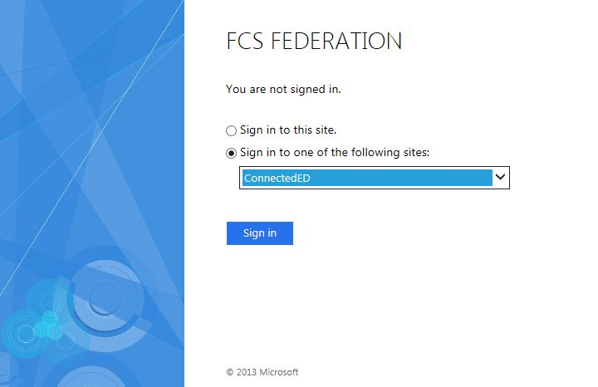
- Students should select ConnectedED and then click sign in

- Students should use:
USERNAME: Student ID number@fcstu.org
PASSCODE: MMDDYYYY
The passcode is the student’s birthdate.

*For example:
USERNAME: 9999999999@fcstu.org
PASSCODE: 01152005

- Press Launch Mobile App in the top right.
- Download eBook.
- Click on the “virtual Bookbag” at the bottom
- When it says Open ebook, complete scavenger hunt.

