9-2 Skills Practice
Translations

Use the figure and the given translation vector. Then draw the translation of the figure along
the translation vector.
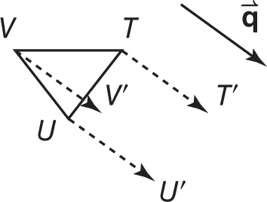
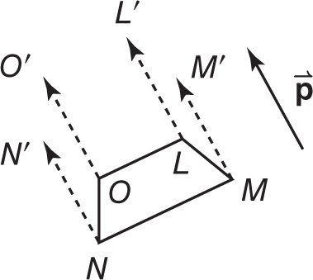
1. 2.

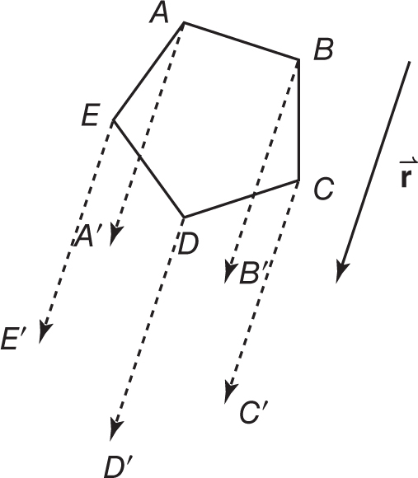
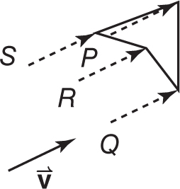
3. 4.

Graph each figure and its image along the given vector.
5. △JKL with vertices J(–4, –4), 6. quadrilateral LMNP with vertices L(4, 2),
K(–2, –1), and L(2, –4); $〈2, 5 〉$ M(4, –1), N(0, –1), and P(1, 4); $〈-4, -3〉$
